CNS
Unit – 5
Q. What is SNMP? Explain SNMP working
SNMP (Simple Network Management Protocol) is like a universal language for network devices (routers, switches, servers) to talk about their health and performance, letting admins monitor and control them from one place, using a Manager (controller) asking Agents (on devices) for data like CPU/memory usage or errors, all standardized so different brands can communicate, ensuring smooth network operation.
What is SNMP? (Simple Terms)
Think of your network as a big city. SNMP is the central dispatch (Manager) that calls different services (Agents on routers, printers, firewalls) to ask, "How are things?" and get real-time updates on traffic, power, or if a fire hydrant is broken.
How SNMP Works (The Process)
- Components:
  - SNMP Manager: Software (like SolarWinds, PRTG) on a central computer that monitors everything.
  - SNMP Agent: Software running on each network device (router, switch, printer) that gathers its own stats.
  - MIB (Management Information Base): A structured database within each device that holds all its manageable data (like CPU load, interface status).
- The Conversation (Request-Response):
  - Manager Asks (GET): The Manager sends a request (a PDU) to an Agent asking for specific info (e.g., "What's the CPU usage on Router X?").
  - Agent Responds (Response): The Agent looks up the data in its MIB and sends it back to the Manager.
  - Manager Sets (SET): The Manager can also send a SET command to change a device's setting (e.g., change a hostname).
  - Agent Alerts (Trap/Inform): If something critical happens (like a link goes down), the Agent can proactively send an alert (Trap) to the Manager without being asked.
- Data Identifiers (OIDs): Each piece of data (like "system uptime") has a unique address called an Object Identifier (OID). The Manager uses OIDs to pinpoint exactly what it needs.
In short: The Manager asks for data using OIDs, Agents retrieve it from their MIBs and send it back, allowing central monitoring and control of diverse devices across the network.
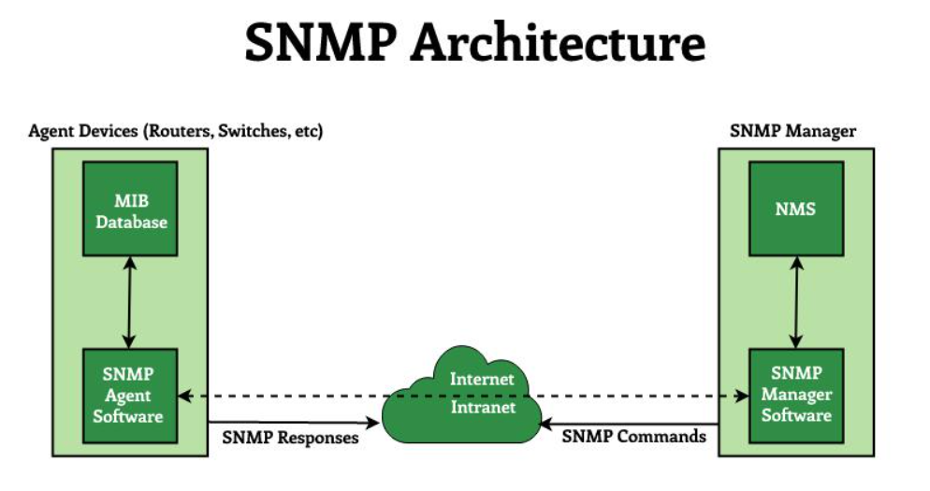
Key Components:
- SNMP Manager (NMS): The central system (computer) that runs management software, requests data from devices, and receives alerts.
- SNMP Agent: Software on managed devices (routers, switches, printers) that collects and stores device information.
- Management Information Base (MIB): A database on the agent, organized as a tree, containing variables (objects) that define device info (like CPU, interface status) for the manager to read.
How it Works:
- The Manager sends a request (e.g., "How many packets?") to an Agent on a device.
- The Agent looks up the corresponding variable in its MIB database.
- The Agent sends the value back to the Manager, which displays it for the administrator.
- Agents can also send automatic alerts (traps) for critical events, like an error, to the Manager.
Q. What is HTTP? Explain HTTP request and reply messages.
HTTP (Hypertext Transfer Protocol) is a fundamental protocol of the Internet, enabling the transfer of data between a client and a server. It is the foundation of data communication for the World Wide Web. HTTP provides a standard between a web browser and a web server to establish communication. It is a set of rules for transferring data from one computer to another.

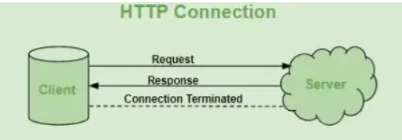
HTTP Request/Response:
HTTP is a request-response protocol, which means that for every request sent by a client (typically a web browser), the server responds with a corresponding response. The basic flow of an HTTP request-response cycle is as follows:
- Client sends an HTTP request: The client (usually a web browser) initiates the process by sending an HTTP request to the server. This request includes a request method (GET, POST, PUT, DELETE, etc.), the target URI (Uniform Resource Identifier, e.g., a URL), headers and an optional request body.
- Server processes the request: The server receives the request and processes it based on the requested method and resource. This may involve retrieving data from a database, executing server-side scripts or performing other operations.
- Server sends an HTTP response: After processing the request, the server sends an HTTP response back to the client. The response includes a status code (e.g., 200 OK, 404 Not Found), response headers and an optional response body containing the requested data or content.
- Client processes the response: The client receives the server's response and processes it accordingly. For example, if the response contains an HTML page, the browser will render and display it. If it's an image or other media file, the browser will display or handle it appropriately.

HTTP Request Circle
- This table explains how HTTP requests work when you visit a webpage and what happens behind the scenes. Here’s a breakdown of the process:

Requested Resource | Resource Type | Server Response
HTML Page | HTML | Server sends HTML file
Style Sheet (CSS) | CSS | Server sends CSS file
Image (JPG) | Image (JPG) | Server sends JPG image
JavaScript Code | JavaScript (JS) | Server sends JS file
Data (XML or JSON) | Data | Server sends XML/JSON data

Q. What is DNS? Explain DNS working.
DNS (Domain Name System) is the internet's phonebook, translating easy-to-remember domain names (like google.com) into computer-friendly IP addresses (like 142.250.186.46), allowing you to access websites without memorizing numbers; when you type a URL, your device asks a DNS server, which then finds the correct IP address through a series of servers (Root, TLD, Authoritative) and sends it back, directing your browser to the right website.
What is DNS?
- Translator: DNS translates human-readable domain names (text) into machine-readable IP addresses (numbers).
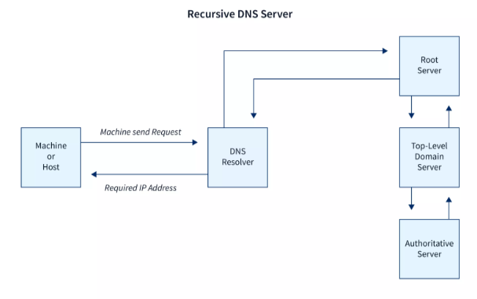
- Internet's Phonebook: Like a phonebook, it maps names to numbers (IPs) so you don't need to remember long IP addresses.

How DNS Works (Simplified Steps):
- You type a URL: You enter www.example.com in your browser.
- DNS Resolver Request: Your computer sends a query to a DNS Resolver (usually your ISP's server) asking for the IP address of example.com.
- Cache Check: The resolver first checks its cache (memory) for the IP. If found, it sends it back immediately.
- Root Server: If not in cache, the resolver asks a Root server, which directs it to the Top-Level Domain (TLD) server (e.g., for .com).
- TLD Server: The TLD server points the resolver to the Authoritative Name Server for example.com.
- Authoritative Server: This final server holds the official record and provides the correct IP address (e.g., 93.184.216.34).
- Response to You: The IP address travels back through the chain to your computer, which then connects to the website's server to load the page.
Key Players:
- Recursive Resolver: Your ISP's server that starts the query process and caches results.
- Root Servers: The top of the hierarchy, directing queries.
- TLD Servers: Manage domains like .com, .org, .uk.
- Authoritative Name Server: The final source of truth for a specific domain's IP.
Q. Write short notes on
i)FTP
File Transfer Protocol (FTP) is a standard network protocol that allows for the reliable and efficient transfer of files between a client computer and a server on a network, such as the internet. It operates on a client-server model and is primarily used for uploading, downloading, deleting, renaming, and managing files remotely.
How it Works (in simple words)
Think of FTP as a digital delivery system where a user (client) connects to a storage warehouse (server) to manage files.
- Client-Server Model: The user's computer runs an FTP client program (like FileZilla), which initiates a connection to a remote FTP server that hosts the files.
- Two Connections: Unlike other protocols like HTTP which use one connection, FTP establishes two separate connections:
  - Control Connection (Port 21): This connection is like the "command center" and stays open during the entire session. It handles commands (like "upload," "download," "list files") and responses.
  - Data Connection (Port 20 in active mode, dynamic in passive mode): This temporary connection is created only when a file transfer (upload or download) actually takes place. It closes once the transfer is complete.
- Authentication: Typically, a user must provide a username and password to access the server's files, ensuring controlled access. Some servers offer "anonymous FTP" for public access files, requiring no specific login.

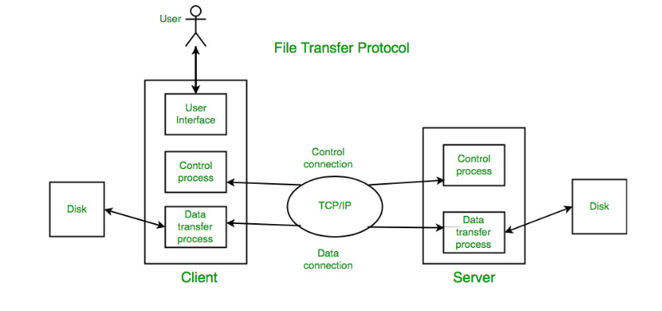
Key Uses
- Website Management: Developers use FTP to upload web pages, images, and other content to a web hosting server.
- Transferring Large Files: It is a very efficient method for transferring large files (like software or backups) that might be too big for email attachments.
- Data Backup: Businesses use FTP to back up important data to off-site or remote servers.
Security Consideration
Standard FTP is not secure because all data, including usernames and passwords, is sent in plain text (unencrypted) over the network, making it vulnerable to interception. For secure transfers, modern alternatives like FTPS (FTP Secure, using SSL/TLS encryption) or SFTP (SSH File Transfer Protocol, running over a secure shell) are highly recommended

ii) TELNET.
TELNET (TELecommunication NETwork) is a foundational, text-based network protocol used for accessing and controlling remote computers or devices over a TCP/IP network as if you were physically sitting in front of them. It operates on a client-server model, typically using TCP port 23.
Key Aspects of TELNET
- Functionality: TELNET provides a simple, bidirectional, interactive command-line interface (CLI) to a remote system. It was designed to allow users to log in to remote hosts and run application programs or manage system resources.
- How it Works (Simplified):
  - A user runs a TELNET client program on their local machine to connect to a remote server by specifying its IP address or hostname.
  - The client establishes a TCP connection with the TELNET server on the remote device.
  - Once connected, the user's keystrokes are sent to the server, and the server's responses are displayed on the client's screen, essentially creating a virtual terminal connection.
  - To ensure compatibility between different types of computer systems, data is exchanged using a universal character set known as the Network Virtual Terminal (NVT) standard.
- Uses:
  - Remote Management: Used by network administrators to configure switches, routers, and servers in controlled environments.
  - Network Testing and Troubleshooting: A simple tool for testing connectivity to specific ports or debugging network services like SMTP or HTTP by manually sending commands.
  - Legacy Systems: Still used to access older systems that do not support modern, secure protocols.
- Security & Limitations (Crucial Point): The primary drawback of TELNET is its lack of encryption. All data, including usernames and passwords, is transmitted in plaintext across the network, making it highly vulnerable to eavesdropping and data interception by malicious actors.
- Modern Alternative: Due to these significant security risks, the Secure Shell (SSH) protocol has largely replaced TELNET for most remote access applications, as SSH provides robust encryption and secure authentication.
Logging in TELNET
The logging process can be further categorized into two parts:
- Local Login
- Remote Login
1. Local Login
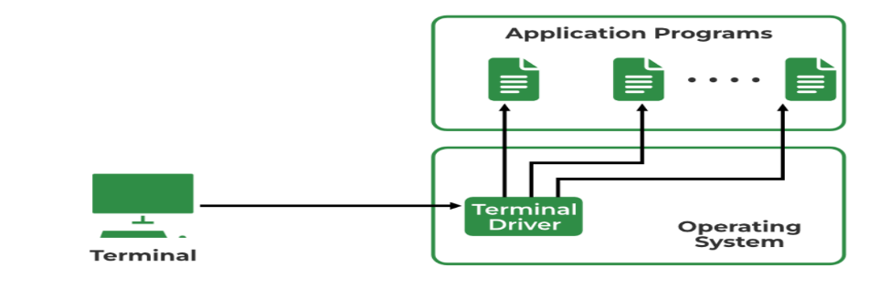
Whenever a user logs into its local system, it is known as local login.
The Procedure of Local Login
- Keystrokes are accepted by the terminal driver when the user types at the terminal.
- Terminal Driver passes these characters to OS.
- Now, OS validates the combination of characters and opens the required application.

2. Remote Login
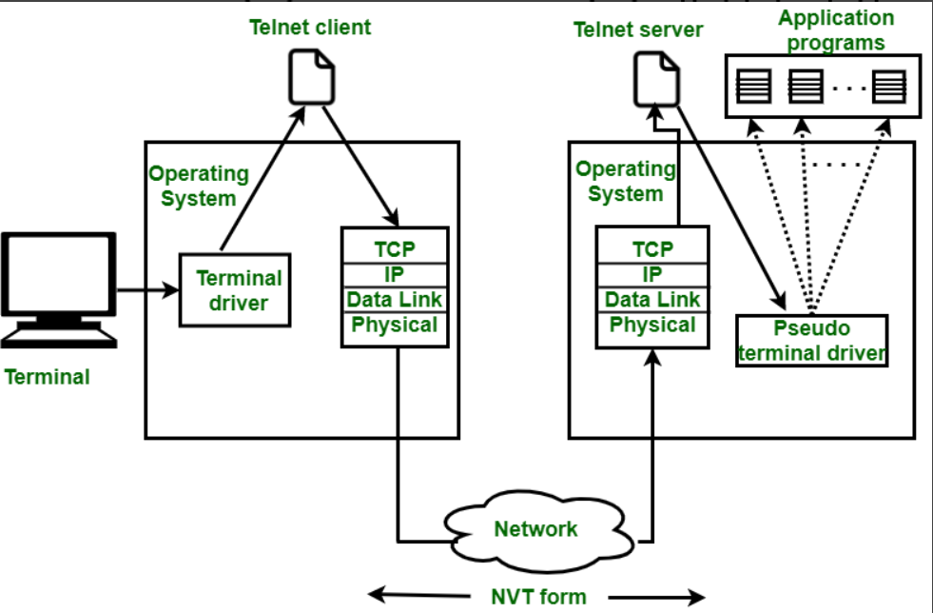
Remote Login is a process in which users can log in to a remote site i.e. computer and use services that are available on the remote computer. With the help of remote login, a user is able to understand the result of transferring the result of processing from the remote computer to the local computer.

The provided text accurately describes the fundamental procedure of a remote login using the TELNET protocol:
- Local Input: A user types characters on their local machine, which are accepted by the local operating system.
- Client Processing: The local OS passes the characters to the TELNET client, which converts them into a standardized format called Network Virtual Terminal (NVT) characters.
- Transmission: The NVT-formatted data is sent through the local TCP/IP stack, across the internet, and received by the remote computer's TCP/IP stack.
- Server Processing: The data is passed to the TELNET server on the remote machine. The server translates the NVT characters into a format understandable by the remote operating system.
- Remote Execution: A pseudo-terminal driver facilitates the interaction, making the remote OS believe the input is from a directly connected terminal. The OS then directs the input to the appropriate application program (like a command shell).
This entire process enables seamless interaction with a remote system as if the user were physically present at its console. Modern systems have largely replaced the insecure TELNET with the encrypted SSH (Secure Shell) protocol, which follows a similar, but secure, client-server model.
Q. What is DHCP? Explain DHCP working with client state diagram.
DHCP (Dynamic Host Configuration Protocol) automates assigning IP addresses and network settings (like gateway, DNS) to devices, preventing manual setup and conflicts, using a four-step DORA (Discover, Offer, Request, Acknowledge) handshake between a client and server, with a client state diagram showing phases from INIT to BOUND, renewing/rebinding leases as needed.
What is DHCP?
- Simple Terms: DHCP acts like a smart receptionist for a network, handing out unique temporary "keys" (IP addresses) and "maps" (network info) to devices (phones, laptops) as they join, so they can talk to each other and the internet.
- What it Does: Assigns IP address, Subnet Mask, Default Gateway, DNS Server.
- Benefits: Central management, fewer errors, efficient IP use, automatic configuration.
How DHCP Works (The DORA Process)
When a device connects, it follows these steps:
- Discover (Client -> Server): "Hello! Is there a DHCP server around?" (Broadcast).
- Offer (Server -> Client): "Here's an IP address (and other info) for you to use for a while!".
- Request (Client -> Server): "Yes, I'd like that IP address you offered!".
- Acknowledge (Server -> Client): "It's yours! Enjoy your IP for the lease period.".
DHCP Client State Diagram (Simplified)
A device transitions through states to get and keep an IP:
- INIT: Device just booted, no IP.
- DISCOVER_WAIT: Sent Discover, waiting for Offers.
- REQUEST_WAIT: Received Offer, sent Request, waiting for ACK.
- BOUND: Got ACK, IP assigned, actively using the network.
- RENEW_WAIT: Lease halfway, trying to renew with original server.
- REBIND_WAIT: Lease almost gone, trying any server to renew/get new.
- RELEASE (Optional): Device leaves network, tells server to free IP.
This cycle ensures devices get addresses automatically and efficiently, with leases renewing or expiring to free up IPs for new devices.
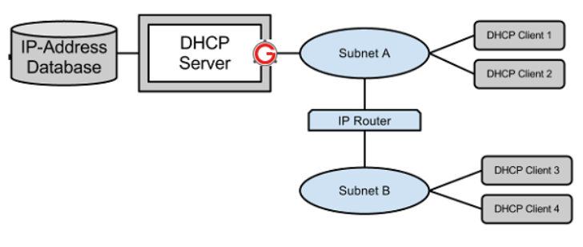

The DHCP process (DORA) starts with the client sending a broadcast Discover (DHCPDISCOVER) to find servers (Step 1), followed by servers responding with an Offer (DHCPOFFER) of an IP (Step 2), the client sending a Request (DHCPREQUEST) to accept one offer (Step 3), and finally the server sending an Acknowledge (DHCPACK) to confirm the lease, giving the client its IP and network settings to start communicating.
Here's a breakdown of the full process, continuing from Step 3:
Step 1: Discover (DHCPDISCOVER)
- Client broadcasts a request to find a DHCP server (Source: 0.0.0.0, Dest: 255.255.255.255).
Step 2: Offer (DHCPOFFER)
- Server(s) respond with a proposed IP address and configuration (Source: Server IP, Dest: 255.255.255.255).
Step 3: Request (DHCPREQUEST)
- Client chooses one offer and sends a DHCPREQUEST to accept it, identifying the chosen server (Source: 0.0.0.0, Dest: 255.255.255.255).
Step 4: Acknowledge (DHCPACK)
- The server sends a DHCPACK, confirming the IP lease and settings, allowing the client to join the network (bound state).
This four-step cycle (Discover, Offer, Request, Acknowledge) ensures a client gets a unique IP address and necessary network information automatically.

Q. Write short notes on POP3 and Webmail.
POP3 (Post Office Protocol 3)
POP3 is a protocol used by email clients to retrieve emails from a mail server and download them to your local device (computer, smartphone, etc.) [1].
- How it Works: The client connects to the server, authenticates, downloads all available messages, and typically deletes the original copies from the server [1, 2].
- Key Feature: It primarily supports one-way synchronization (server to device). Once an email is downloaded and deleted from the server, it is usually only accessible on the specific device it was downloaded to [1, 2].
- In Short: It's like collecting physical mail from a post office box and bringing it home; the box is then empty [1].
Webmail
Webmail is a method of accessing and managing email directly through a web browser (like Chrome, Safari, or Firefox) without the need to install and configure a dedicated email client application [1, 2].
- How it Works: Emails are stored entirely on the provider's remote servers and are accessed via an internet connection and a web interface (e.g., Gmail, Outlook.com, Yahoo Mail) [1, 2].
- Key Feature: It supports two-way synchronization. Since everything is stored on the server, you can access your inbox, sent items, and folders from any device, anywhere, and all changes (sending, deleting, organizing) are instantly reflected across all access points [1, 2].
- In Short: It's like having an online account you can log into from anywhere to view your emails, which always remain stored in "the cloud" [1].
Summary of Differences
Feature | POP3 | Webmail
Access Method | Requires an email client application (e.g., Thunderbird, Outlook desktop app) [2]. | Uses a web browser directly [2].
Storage Location | Primarily on your local device [1, 2]. | On the email provider's remote servers [1, 2].
Synchronization | Limited; generally one-way download | Full; two-way sync across all devices [1, 2].
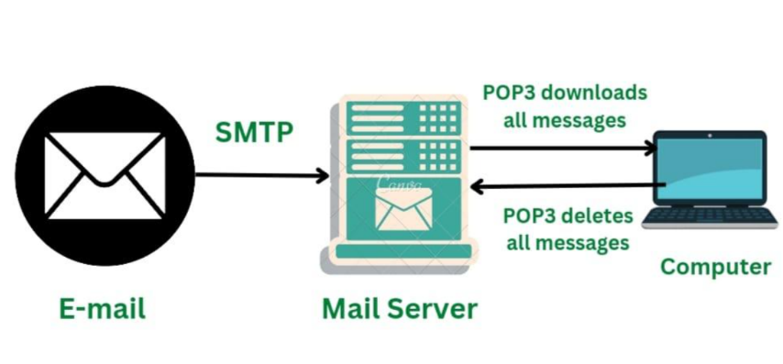

Q. Write short notes on MIME
Multipurpose Internet Mail Extensions (MIME) is an essential standard that expands the limited capabilities of the original Simple Mail Transfer Protocol (SMTP), allowing email systems to handle a wide range of file types beyond plain text [1, 2]. In simple terms, MIME is the system that lets you send things like images, videos, audio files, application documents (like PDFs or Word files), and emails with complex formatting (like different fonts and colors) as attachments or inline content [1, 3].
It acts as a translator, packaging non-textual data so that email servers can send it and the recipient's email client can understand how to unpack and display it correctly [1, 3].
Key Components of MIME
MIME works by adding specific "header" fields to an email message that the recipient's email software uses to determine the content type and how to handle it [2]. The main components are:
- MIME-Version: A simple header that indicates the message is formatted using the MIME standard (usually MIME-Version: 1.0).
- Content-Type: This is the most crucial part. It specifies the exact type of data being sent using a standard format like type/subtype (e.g., image/jpeg, text/html, application/pdf) [3, 2]. This tells your computer whether to open the data as a picture, a webpage, or a document.
- Content-Transfer-Encoding: Because older email systems could only handle basic text characters (specifically 7-bit ASCII), MIME specifies how the binary data (like an image file) is converted into a safe, transmittable format (like base64 or quoted-printable) and then back again [3, 2].
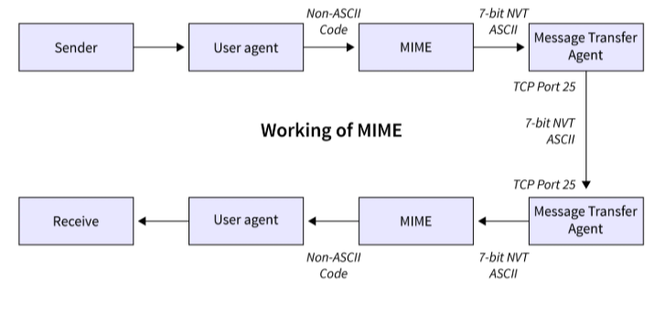
- Content-Disposition: This header suggests how the email client should display the data—either as an inline part of the message body (like an embedded image) or as an attachment that needs to be downloaded and opened separately [1].

Q. Differentiate between POP & IMAP protocol.
Post Office Protocol (POP3) | Internet Message Access Protocol (IMAP)
POP is a simple protocol that only allows downloading messages from your Inbox to your local computer. | IMAP (Internet Message Access Protocol) is much more advanced and allows the user to see all the folders on the mail server.
The POP server listens on port 110, and the POP with SSL secure(POP3DS) server listens on port 995 | The IMAP server listens on port 143, and the IMAP with SSL secure(IMAPDS) server listens on port 993.
In POP3 the mail can only be accessed from a single device at a time. | Messages can be accessed across multiple devices
To read the mail it has to be downloaded on the local system. | The mail content can be read partially before downloading.
The user can not organize mail in the mailbox of the mail server. | On the mail server, the user can directly arrange the email.
The user can not create, delete,e or rename email on the mail server. | The user can create, delete,e or rename an email on the mail server.
It is unidirectional i.e. all the changes made on a device do not affect the content present on the server. | It is Bi-directional i.e. all the changes made on the server or device are made on the other side too.
It does not allow a user to sync emails. | It allows a user to sync their emails.
It is fast. | It is slower as compared to POP3.
A user can not search the content of mail before downloading it to the local system. | A user can search the content of mail for a specific string before downloading.
It has two modes: delete mode and keep mode.  - In delete mode, the mail is deleted from the mailbox after retrieval.  - In keep mode, the mail remains in the mailbox after retrieval. | Multiple redundant copies of the message are kept at the mail server, in case of loss of message on a local server, the mail can still be retrieved
Changes in the mail can be done using local email software. | Changes made to the web interface or email software stay in sync with the server.
All the messages are downloaded at once. | The Message header can be viewed before downloading.

